# Prepress Studio App V1.0 – Release Notes

Features Provided:

1. Cutout of images
2. Restricted to be used on licensed machine only

# Installation Steps

1. Get license key generated for your target system by running generate_license.exe on the target system on which prepress studio software will be executed.
2. Unzip prepress_studio.zip, following directory structure should get created:

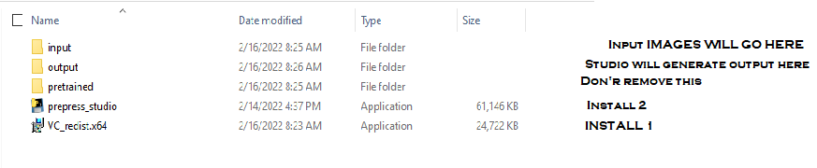

1. Install VC_redist.x64.exe by double clicking
2. Install prepress_studio.exe by double clicking

# Using Software Steps

1. Copy images in input folder
2. Double click prepress_studio , cutouts and the corresponding masks will be generated in output folder

NOTE: If you want to see messages while prepress_studio is executing, start the executable from command prompt by changing directory to the folder where prepress_studio.exe is installed and typing the prepresess_studio.exe name on the prompt.

NOTE2: For faster results, you can convert 100 files at a time in input folder. Make sure you remove those files from input folder, before handling next batch.

# Known Limitations

1. For CMYK images, only mask file will be generated
2. For large images , the messages on command prompt will take time to display
3. For objects with shining surfaces , the output won’t be correct
4. For objects with colors matching the background, the cutout would be distorted
5. Following error message gets generated in the beginning which you can ignore

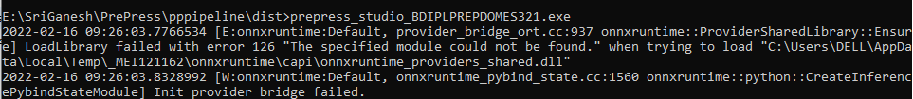

1. Any error message after the above, needs our attention and should be communicated back to us